# Creating a Storage Account

## Lab Overview

In this lab you will create a storage account using the Azure Preview Portal.

## Prerequisites

* Microsoft Azure Subscription: <http://azure.microsoft.com/en-us/pricing/free-trial/>

## Time Estimate

* 15 minutes

## Table of Contents

Creating a Storage Account 1

Lab Overview 1

Prerequisites 1

Time Estimate 1

Table of Contents 1

Exercise 1: Login to the Azure Management Portal 1

Exercise 2: Create a Storage Account 2

Lab Summary 5

## Exercise 1: Login to the Azure Management Portal

In this exercise you will use your Microsoft or Organization account to login to the Azure management portal to start the lab exercise.

1. Open your browser and navigate to <http://portal.azure.com>
2. Enter the credentials for the account associated with your Microsoft Azure subscription.

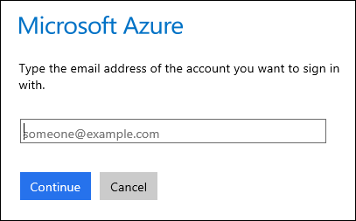

1. If your account is associated with an organization account and a Microsoft account you may be prompted to choose which one to authenticate with for your Microsoft Azure account.

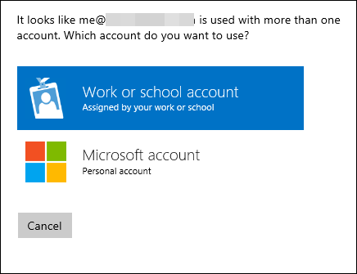

## Exercise 2: Create a Storage Account

In this task you will create a new storage account that you can use for the exercises in this course.

1. Click the **+NEW** button in the bottom left of the portal.



1. Click Data + Storage, then Storage.

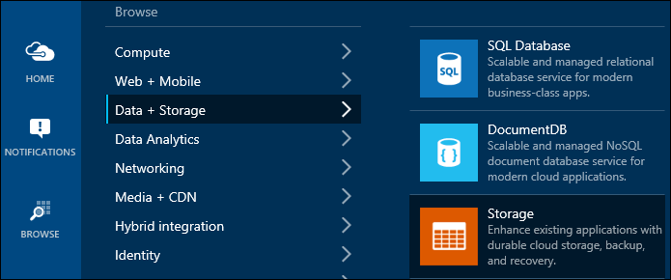

1. This will open a blade to the right for the storage account.

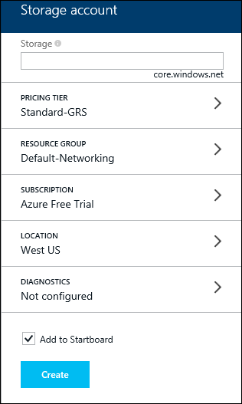

1. In the text field, enter a name for the storage account. This must be unique across all of Azure. If it is not, it will display an error. I’m going to use the name fabrikamtest. Next, if you click on the PRICING TIER, it will show you the most commonly used pricing plans. (Click View All to see all of them.) I’m going to select Locally Redundant, because I’m only going to use the account for testing. When you’re done, click Select at the bottom of the blade.

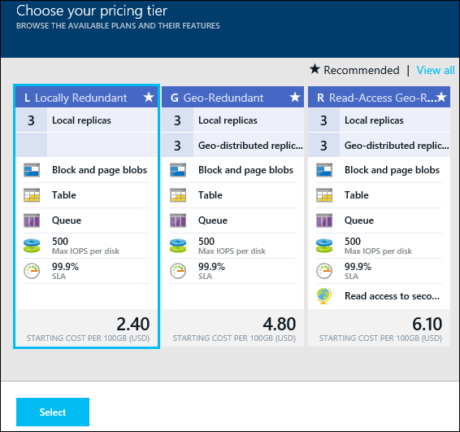

1. Next, click on RESOURCE GROUP. In the blade that comes up to the right, you can either create a new resource group or select one you already have. If you aren’t familiar with resource groups, click the Learn More link in the top of the blade. I’m going to create a new resource group, I’ll call it OpsgilityTraining and click OK at the bottom of the blade.

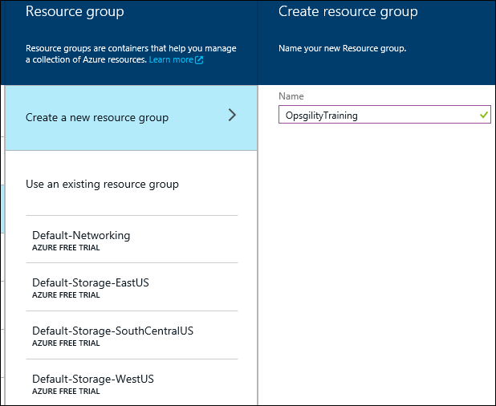

1. Under SUBSCRIPTION, it should show the subscription you logged into by default. If you administer multiple subscriptions, you can select which one the storage account should belong to
2. Next, select a LOCATION – the one closest to you will probably have the least latency.
3. For DIAGNOSTICS, leave that turned off for now. We’ll look at that later in this course.
4. After you’ve specified all of the information, click Create at the bottom of the blade. It will create the storage account. If you check Add to Startboard, it will add the storage account to your Startboard.

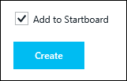

## Lab Summary

In this lab you have created a storage account that can be used for the hands-on labs in this course.